STEP 1: Create Java Program/process named (myapp.java),just for practice.

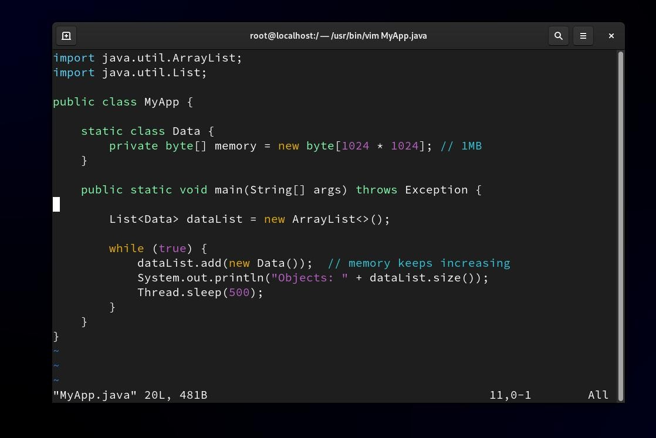

Make sure its created in your system
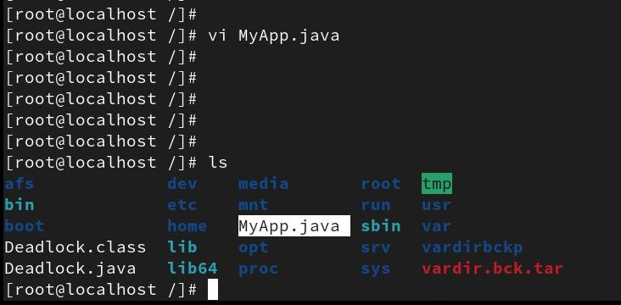

STEP 2: Compile and Run (How it works in simple terms):

- Program starts with 500 MB memory
- As it needs more memory, JVM increases it
- Maximum it can use is 2 GB
- If memory exceeds 2 GB → OutOfMemoryError
- Process started in background
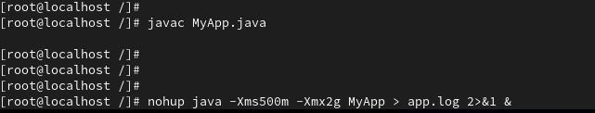

Step3.Memory Analysis (Using free -m)

We observed system memory at different stages while running a Java program that consumes memory.
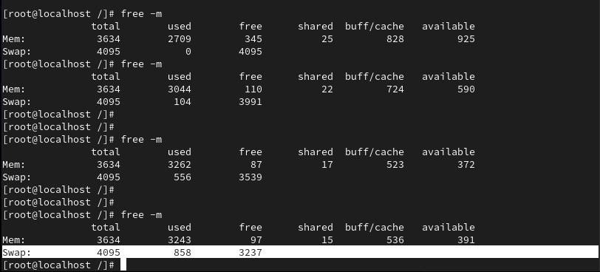

Stage 1: Normal ConditionUsed: 2709 MB
Free: 345 MB
Available: 925 MB
Swap: 0 MB
System is healthy
Enough memory available No swap usage
✔ This is a normal state

Stage 2: Memory Increasing
Used: 3044 MB
Free: 110 MB
Available: 590 MB
Swap: 104 MB
Memory usage increased Available memory decreased Swap started being used
This indicates memory pressure is starting

Stage 3: High Memory Usage
Used: 3262 MB
Free: 87 MB
Available: 372 MB
Swap: 556 MB
Very low free memory Available memory dropping fast
Swap usage increased significantly System is under high memory pressure

Stage 4: Critical Condition
Used: 3243 MB
Free: 97 MB
Available: 391 MB
Swap: 858 MB
RAM is almost full Heavy swap usage
System performance becomes slow System is near Out Of Memory (OOM)

Step4.Identify running processes using top
The top command is used to monitor system performance in real time.
- It shows:
  - PID (Process ID)
  - CPU usage
  - Memory usage (%MEM, RES)
  - Running processes

From the output:
- The Java process (java) is consuming high memory (~1.5 GB, ~43%)
- This indicates the application is memory intensive

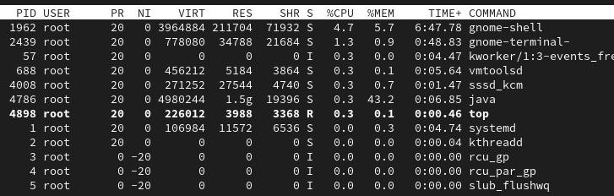

Identify Java process using jps
jps -l,This command lists all Java processes with their PID and class name
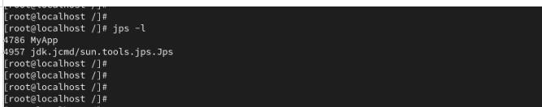

Step 5: Analyze threads of the process(top -H -p 4786)
This command shows threads (TIDs) of a specific process

Each thread has:

  - TID (Thread ID)
  - CPU usage
  - Memory usage

This command does not identify the root cause of memory issues,Memory-related problems cannot be identified using TIDs.

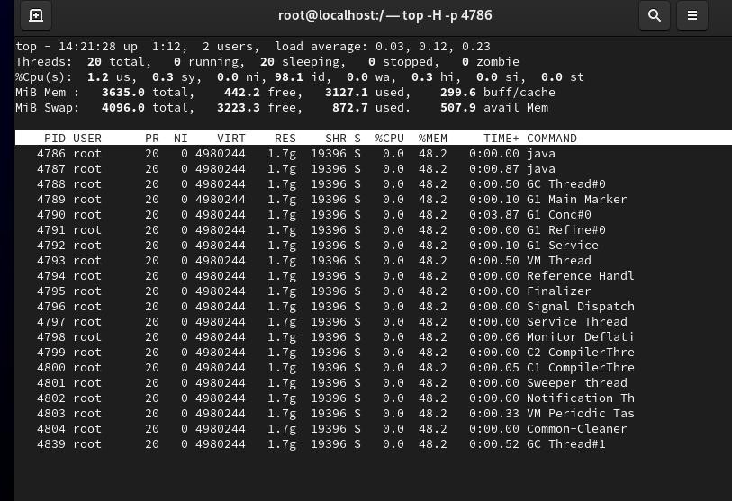

Step 6: To analyze the memory issue, a heap dump of the running Java application was taken using the jmap command.
The command jmap -dump:format=b,file=/tmp/heapdump.hprof 4786 was executed, where the PID of the Java process was obtained earlier. This command generates a heap dump file that contains a snapshot of all objects present in memory at that time.
After executing the command, the heap dump file was verified using ls /tmp, which confirmed that the file was successfully created. The generated heap dump can then be used for further analysis using tools like VisualVM or Eclipse MAT to identify memory usage patterns and detect possible memory leaks.

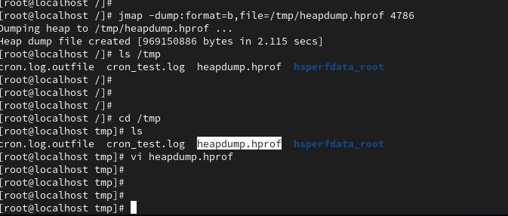

Step7: VisualVM was installed on the system,to read heap dump file

by downloading and extracting the official VisualVM package. After installation, the tool was launched using the visualvm executable. The heap dump file (heapdump.hprof) was then loaded into VisualVM using the “File → Load” option. Once loaded, VisualVM processed the file and provided a detailed view of memory usage, including classes, object count, and memory consumption. This helped in identifying the objects consuming maximum memory and understanding the cause of the memory issue.
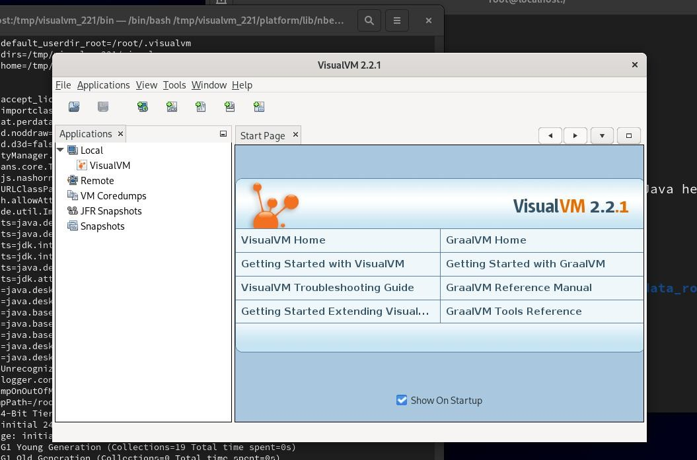

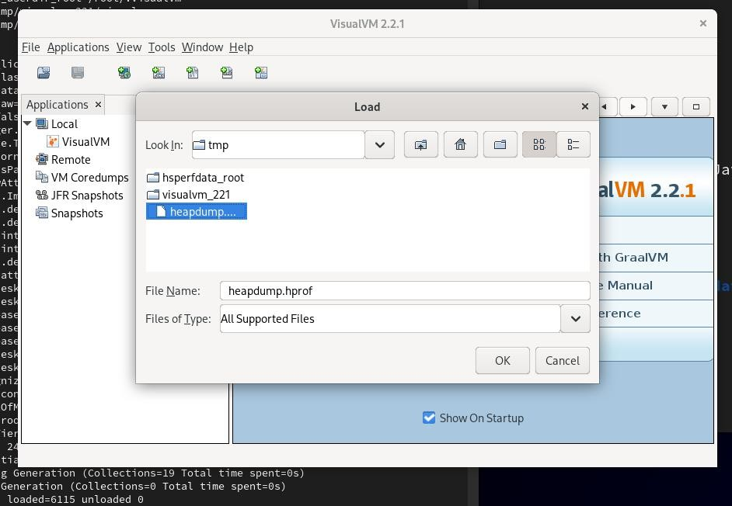

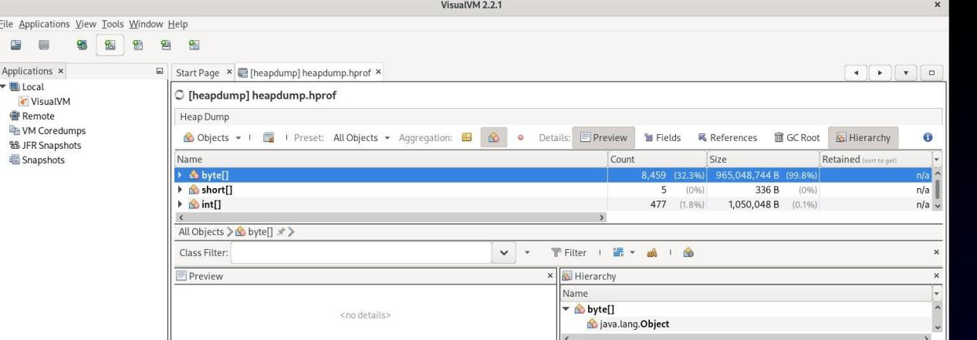
Step8: Interpretation (VERY IMPORTANT)
Almost entire memory (99.8%) is used by byte[]
✔ This means:
- Your program is creating large byte arrays
- They are not getting freed
- Memory is getting filled

What this indicates
This is either:

✅ Case 1: Memory Leak
- Objects are kept in memory (e.g., stored in list/map)
- Garbage collector cannot clean them

✅ Case 2: Heavy memory usage
- Program intentionally creates large data
- But exceeds heap limit

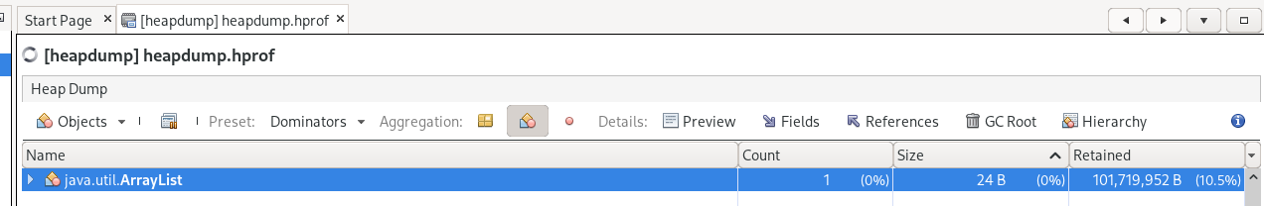

Final conclusion: One ArrayList object is holding large amount of memory because it contains many large objects (byte arrays)

- The retained size (~101 MB) indicates that if this ArrayList is removed,
a significant portion of memory can be freed.
- The ArrayList contains many elements (possibly large objects), or
- It is indirectly retaining objects through references.

Step9: You can also check the application logs to identify errors such as OutOfMemoryError when the application crashes.

